1. **PhotoDB User Manual**
   1. Overview

The PhotoDB program was originally designed as means of keeping track of a large number of digital photographs . Over the years it has grown to include the ability to also track video files, audio files, DVDs and documents such as MS Word, PowerPoint, text files and others.

It is easy to find photos and documents based on a large number of criteria such as file name, file location, file creation date or date photo was taken, date record was created, date record was updated, key words, copyright owner, file size, photo height, photo width, the latitude & longitude that a photo was taken at, document type (Word, Excel, PowerPoint, JPEG, etc).

Video and audio files can be searched on a scene-by-scene basis to look for key words, dates, etc.

Photos and documents can be searched for using simple or complex Boolean expressions with sophisticated functionality built in to simplify looking for locations, numeric comparisons, info contained in the EXIF data of a digital photo, and much more.

* 1. Tab Sheets
     1. Filter Tab Sheet
        1. Filtering Options

**When PhotoDB opens, it will open to the “Filter” tab sheet.** Each field that is filled in works as a filter to select records in the database. For example, in the example, the *Low Month, High Month, Low Year, High Year* and *Key words*  fields are filled in. This will select only records with a *Month* of 7, a *Day*  of 1, and which contain the *Key Words* “Birthday”.

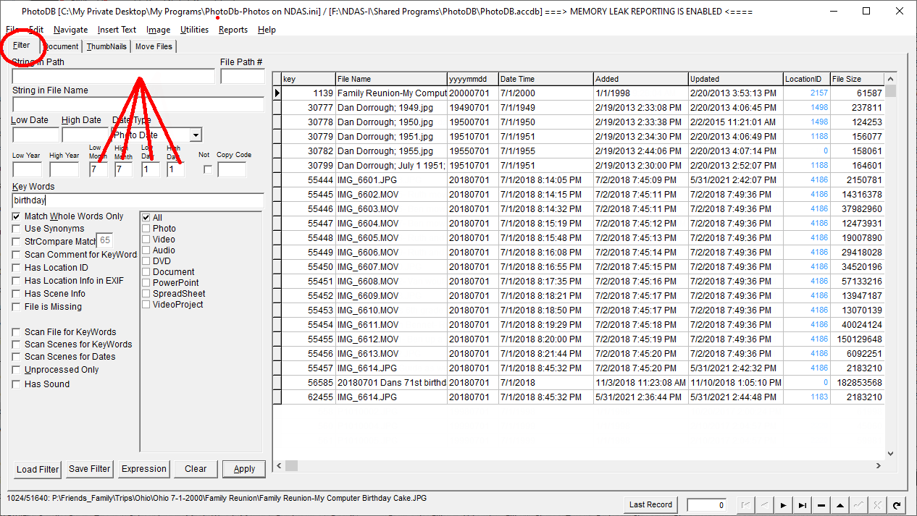

**Other options include:**

|  |  |
| --- | --- |
| *String in Path* | *Select only records which include the indicated string in the File Path* |
| *File Path #* | *If a number is entered into this field, only files in the specified folder number (and optionally) its sub-folders will be selected. The folder number can be seen on the Photos page to the right of the File Path field. It can also be found by selecting a folder in the left-hand pane on the Move Files tab sheet.* |
| *String in FileName* | *Select only records which include the indicated string in the File Name* |
| *Low Date* | *Select only records which are on or after the indicated date* |
| *High Date* | *Select only records which are before or on the indicated date* |
| *Date Type* | *Select which date to filter on. The possibilities are: Photo Date, Date Added, Date Updated, or Photo Date + Time* |
| *Low Year* | *Select only records which are in or after the specified year* |
| *High Year* | *Select only records which are in or before the specified year* |
| *Low Month* | *Select only records which are in or after the specified month* |
| *High Month* | *Select only records which are in or before the specified month* |
| *Low Day* | *Select only records which are in or after the specified day* |
| *High Day* | *Select only records which are in or before the specified day* |
| *Copy Code* | *Select only records which are have the specified Copyright code* |
| *(not) Copy Code* | *Select only records which do not have the specified Copyright code* |
| *Key Words* | *Select only records which include ALL of the indicated Key Words* |

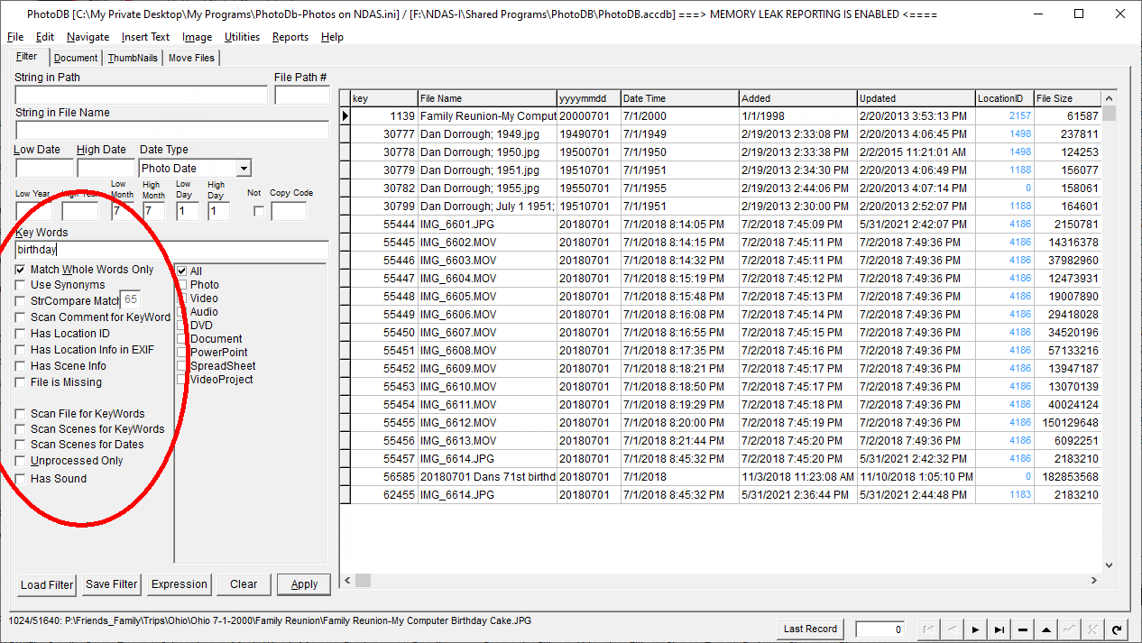

**The following options are available for filtering:**

|  |  |
| --- | --- |
| *Match Whole Words Only* | *If checked, all Key Words must be found. If not checked, the Key Words field will be searched for the exact specified string value* |
| *Use Synonyms* | *If checked, Key Words will be found if they match associated words in the synonyms table* |
| *StrCompare Match* | *If checked, words can match if they are only similar to the Key Words (within specified matching percentage).* |
| *Scan Comment for Key Words* | *If checked, the Comments field will be searched in addition to the Key Words field* |
| *Has Location ID* | *If checked, only records which have a non-zero value in the Location ID field* |
| *Has Location Info in EXIF* | *If checked, only photos which have location info in the EXIF data will be found* |
| *Has Scene Info* | *If checked, only records which have associated scene information records will be found* |
| *File is Missing* | *If checked, only records referring to a missing data (Photo, text, PDF, etc) file will be found* |
| *Scan File for Key Words* | *If checked, the associated text file (if any) will also be searched for the Key Words* |
| *Scan Scenes for Key Words* | *If checked, the associated Scenes records will also be searched for the Key Words* |
| *Scan Scenes for Dates* | *If checked, the associated Scenes records will also be searched for the Dates* |
| *Unprocessed Only* | *If checked, only records which do not have an Update Date will be found* |
| *Has Sound* | *If checked, only records which have an associated sound (WAV) file with the same name will be found.* |
| *Expression* | *Clicking this button will invoke the Expression builder and allow entry of a boolean expression to be used in filtering. For example, to select only photos whose height is greater than their width, the following expression:* Height > Width *could be used. See “Expression Builder” for details.* |

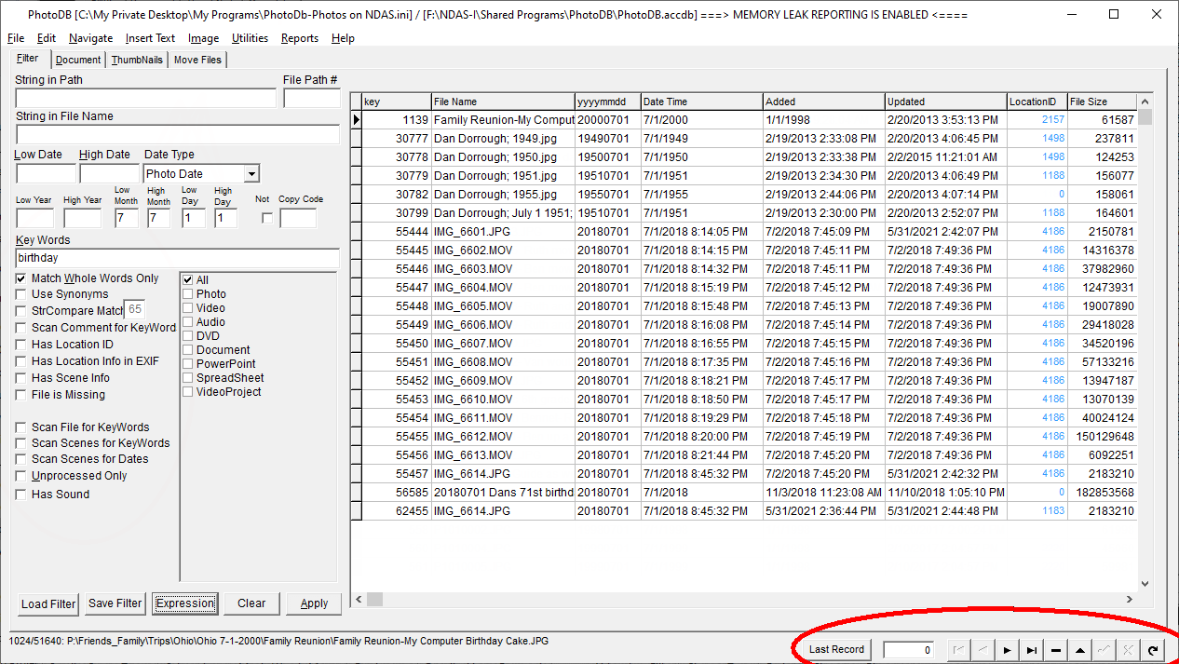

The selected record can be changed in multiple ways. These include:

|  |  |
| --- | --- |
| *Last Record* | *Move to the last record viewed* |
| *(record number)* | *Enter the record number to be selected* |
| *(first record)* | *Move to the first record in the file* |
| *(previous record)* | *Move to the record which precedes the current record* |
| *(delete record)* | *Delete the current record* |
| *(next record)* | *Move to the record which follows the current record* |
| *(post record)* | *Save changes to the current record to the database* |
| *(cancel changes)* | *Revert the record to last saved state* |
| *(refresh database)* | *Update the database to include changes made by other users or processes* |

Record movement can also be made using the Navigate Menu:

The Navigate menu can also be used to move from record to record, delete the current record and post the current record. The key shortcuts are most useful on the “Document” tab.

Mark/Next will set the “Date Updated” field to the current date/time and then move to the next record. This is useful for marking a record as “processed”.

The “Order By” sub menu is used to select the order used to access the selected records. These include:

|  |  |
| --- | --- |
| File Name | Records are sorted by file name |
| Path / Name | Records are sorted by the file path and name |
| Photo Date | Records are sorted by the photo date YYYYMMDD. Sub-menu to sort ascending or descending. |
| Photo Date / Time | Records are sorted by the photo date and time. Not all records have a Photo Date/Time since the date might only be a year or year and month. Sub-menu to sort ascending or descending. |
| File Size | Records are sorted by the file size in bytes |
| (Recno) | Records are not sorted |
| Date Updated | Records are sorted by the date/time when last updated |
| Date Added | Records are sorted by the date/time when added |
|  |  |
| Latitude | Records will be sorted by Latitude. Sub-menu to sort ascending or descending. |
| Longitude | Records will be sorted by Longitude. Sub-menu to sort ascending or descending. |
| Media Length | Records will be sorted on the length of the media (video or audio) |
| Custom Key | Records will be sorted on the “Custom Key” field |
| Distance from Location | Records are sorted by the distance from a location which will be requested by Latitude and Longitude |

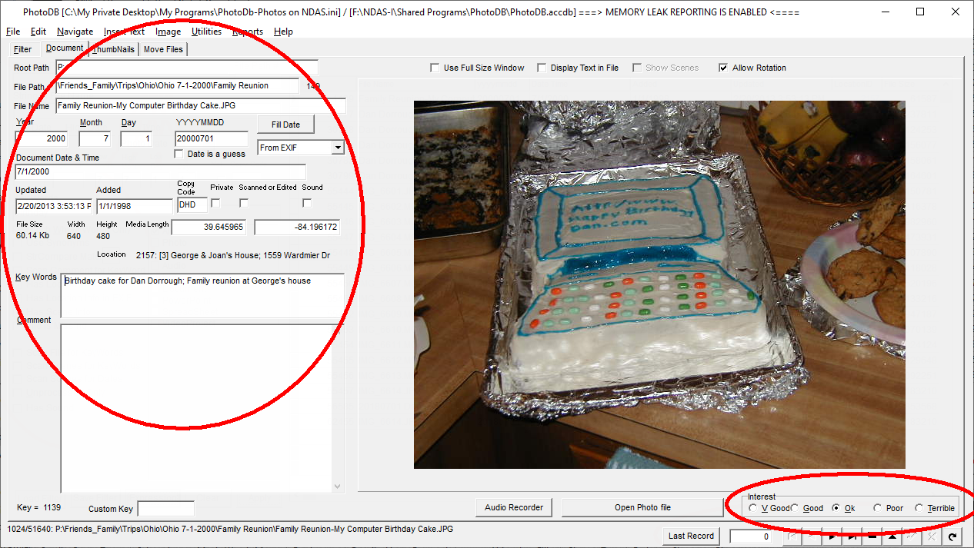

**The data fields associated with each record include the following:**

|  |  |
| --- | --- |
| Root Path*-* | *location of the folder* |
| File Path*-* | *path relative to the root path* |
| File Name*-* | *the name of the file* |
| Year*-* | *year associated with the file* |
| Month*-* | *month associated with the file* |
| Day*-* | *day associated with the file* |
| PhotoDate*-* | *date as YYYYMMDD (this will update Photo Date/Time if a valid date)* |
| Document Date & Time*-* | *date as MM/DD/YYYY (this will update the PhotoDate)* |
| Updated*-* | *date the file was last updated* |
| Added- | date the file was added |
| Copy Code*-* | *3-letter copyright code* |
| Private*-* | *checked if this is a “private” file* |
| Scanned or Edited*-* | *checked if this image was scanned rather than taken from a digital camera* |
| Key Words*-* | *Key words to be associated with this file* |
| Comments*-* | *comments associated with file but not usually searched in a Key Word search* |
| Key*-* | *record key for this record* |
| Custom Key- | *“custom” key with meaning assigned by user* |
| Interest- | *Quality rating* |
| File Size | The size of the associated file. This is read-only. |
| Width | The width of the associated photo (in Pixels) |
| Height | The height of the associated photo (in pixels) |
| Media Length | The length (time) of an audio file or a video file |
| Location | Latitude and longitude |
| Location ID | ID of the associated location record |

**The *Use Full Size Window***check box will open a full-size, re-sizable window to display the image.

**The *Display Text in File***check box will open a full-size, re sizable window to display the contents of a text file. Such information, perhaps taken from a PDF file must be added to the database using one of the Utilities functions.

The “**Show Scenes**” checkbox will open a browse record or “scene” information for video (and/or audio) files.

The “**Allow Rotation**” button will allow photos to be automatically rotated to the “correct” orientation.

The “**Audio Recorder**” button activates an audio recorder which will create a .wav file with the same base file name as the photo / document.

The “**Open…**” button will allow the referenced document / photo to be opened for editing by an external application (such as FotoCanvas or PhotoShop).

Right-clicking on the Photo will display the available options:

1. **Rotate**
   1. Rotate Right 90
   2. Rotate Left 90
   3. Rotate 180
2. **Use full Size Window**- a new full-size window will be created and used to display the photo.
3. **Photo Editor…**- This will open your primary editor as specified on the Options screen as “Photo Editing Program”
4. **Alternate Photo Editor…**- This will open the “Alternate Photo Editor” as specified on the Options dialog as “Alternate Photo Editing Program”
5. **Edit Thumbnail**- This will open the thumbnail file (TN\*.TN) for manual editing.
6. **Play Audio**- If the photo (/document) has an associated audio (*.WAV) file, this will play the audio.
7. **Create Thumbnail** – this will create (or recreate) the thumbnail associated with this photo (/document).
8. **Rate this photo, Next**- this is a quick and easy way to rate a group of photos. After selecting a rating for each photo, the record will be saved and advanced to the next selected record.

**The *Show Scenes* check box will open another window which will display scene-by-scene information for the associated video file.** This check box will only be enabled if such information has been added.

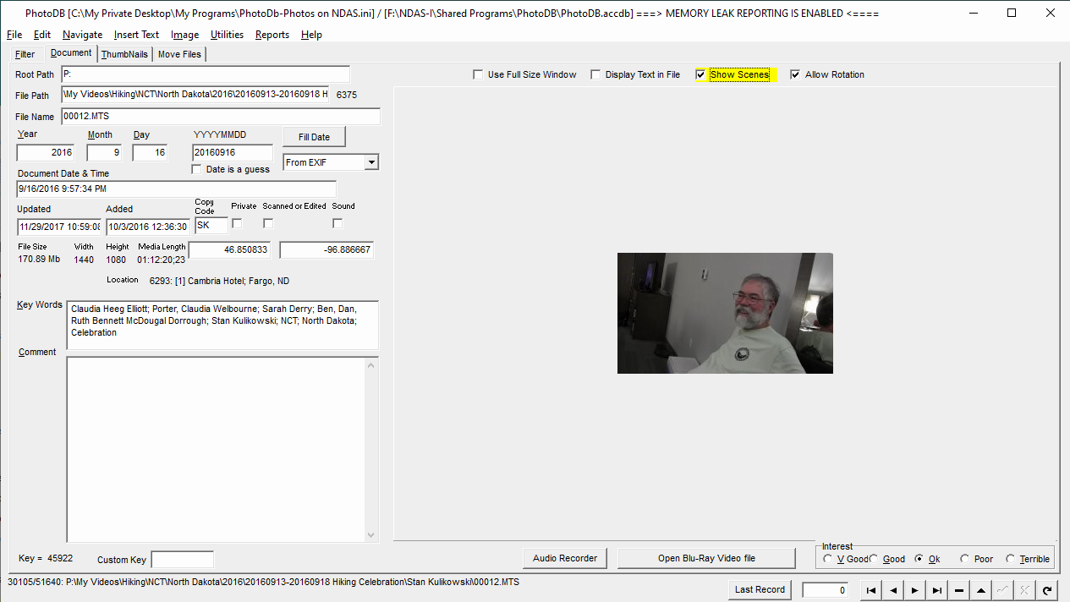

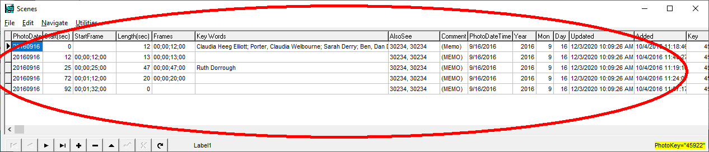

**Scene information includes:**

|  |  |
| --- | --- |
| Photo Date | *date video was taken* |
| *Start (sec)* | *the start time, in seconds, of the scene* |
| Start Frame | *the starting frame of the scene in the format: hours; minutes; seconds; frames.*  *This information is an alternative representation of the same information shown in “Start (sec)”. Updating one will automatically update the other when the record is posted.* |
| Length (sec) | *the length of the scene in seconds* |
| Frames | *the total length of the scene in frames. This information is an alternative representation of the same information shown in “Length (sec)”. Updating one will automatically update the other when the record is posted.* |
| Key Words | *key words associated with this scene.*  *This information will not be included in a “Key Words” search unless the “Scan Scenes for Key Words” checkbox is selected on the filter page.* |
| Also see | *this is a user defined link to related videos and/or scenes.* |
| Comments | *user specified comments (double-click this field to see the comment)* |
| Photo Date Time | *when scene was taken* |
| Year | *Year scene was taken* |
| Mon | *month scene was taken* |
| Day | *day scene was taken*  *This Year, Month,Day information will be automatically updated when using Recaculate Scene Lengths is used.* |
| Updated | *date the scene record was last updated* |
| *Added* | *Date that the scene record was added* |
| Key | *Key linking to the parent recorder* |
| *ID* | *Key to this Scene information record* |

The menus associated with this *Browse Scenes* screen include:

File

Export – *export the selected Scene records*

Print- *allows columns to be selected and then writes all of the selected records to a text file*

Edit

Find- search within the scene table for a string

Find Again- search for the next occurrence of the string

Copy Record- copy the current record

Append and Paste Record- append a new blank record and paste the current copied record into it

Navigate

Filter Options– *allows record filtering information to be entered*

Clear Filter Options

Order By- *allows records to be sorted by*

*Photo Date*

*Photo Key*

*Date Added*

*Date Updated*

Utilities

Copy scenes from another Photo Table Record

Recalculate Scene Lengths

Calculate Scene Lengths based on Scene Starts (sorted by Date)

Set Video Length...

**The Thumbnails Tab Sheet displays Thumbnails for the currently selected photos.**

By default, only 100 thumbnail photos will be shown.

To display more photos, change the *Max Photos to Show* edit box and then click the *Refresh* button.

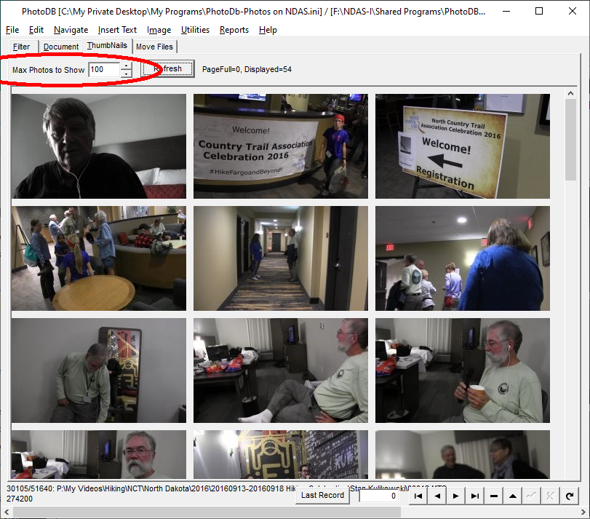

Note: *The Thumbnails view needs work and may not behave as expected.*

**The *Move Files*  Tab Sheet can be used to move files from one folder to a different folder.** The Tree view gives an overview of all of the folders currently in the database. Clicking on a folder in the left-hand pane, will display all of the files in that folder in the right-hand pane. To move a file from one location to another, select the file in the right-hand pane and drag and drop it to a different folder in the LEFT hand pane.

Clicking a folder in the left-hand pane will select it and display the associated folder number (6443 in the example).

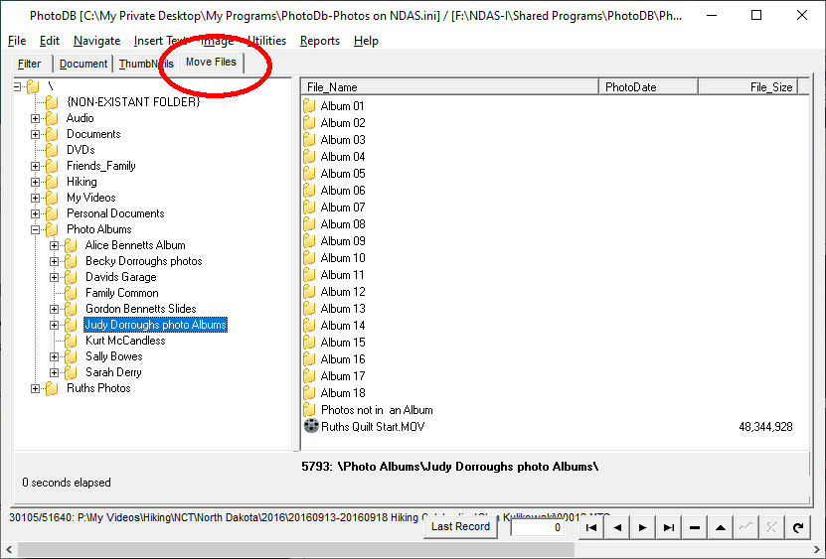

**The Expression builder is used to create expressions.** It can be used when filtering records and in other places in the program. When filtering, only if the expression evaluates to true for the associated record, will the record be selected.

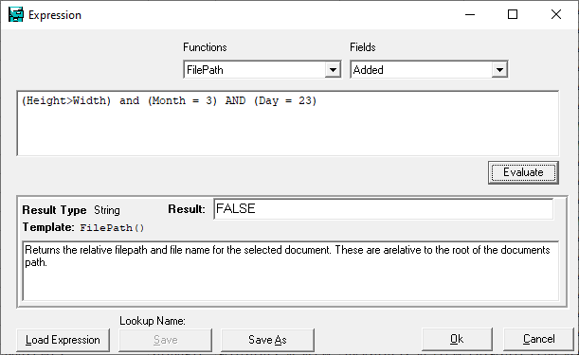

All of the fields in the associated table can be used when building the expression. *See the* Photo *documentation for a list of the available fields and their meaning. Expressions can be complex and use parentheses for nesting. For example, the following expression:*

*(Height>Width) and (Month = 3) AND (Day = 23)*

could be used to select only “portrait” photos taken on March 23 of any year.

Expressions can be saved using the “Save” or “Save As” buttons. Previously saved expressions can be reloaded using the “Load Expression” button.

**The following functions are available:**

|  |  |
| --- | --- |
| Abs | Absolute value of the argument |
| ApproxEqual([Float], [Float], [Float]) | True if the first two arguments are approximately equal within the tolerance of the third argument. For example: ApproxEqual(Width, 640, 5) would select all photos that are within 5 pixels of 640 pixels wide |
| Consonents([Str]) | Returns only the consonants from the argument. For example: Consonants(“Smith”) WOULD return the string “Smth” |
| ContainsAny([Str], [Chars]) | Returns true if the first string contains any of the characters in the second string. For example: ContainsAny(“quit”, “q”) would return true, but ContainsAny(“stop”, “q”) would return false. |
| ContainsAnyPunct([str]) | Returns true if the argument contains any punctuation. For example, ContainsAnyPunct(CopyR_ID) would select only records in which the “Copyright ID” included punctuation characters. |
| DayOf([Date]) | Returns the day from the date. For example: DayOf({3/23/1987}) returns 23 |
| DaysInMonth([Date]) | Returns the number of days in the month. For example: DaysInMonth(3/3/2017) returns 31 |
| Empty([Str]) | Returns TRUE if the argument is an empty string. For example: Empty('abc') would return FALSE. |
| EncodeDate([year], [month], [Day]) | Encodes the numeric values to a date. For example, EncodeDate(1987, 3, 23) returns the date {3/23/1987} |
| EXIFInfo([Str]) | Returns the EXIF data for the specified field for the current record. For example: EXIFInfo('Make') might return 'Canon' |
| ExtractFileBase([Str]) | Returns the base portion of the path\file name. For example: ExtractFileBase('c:\temp\IMG_0002.jpg') would return “IMG_0002” |
| ExtractFilePath([Str]) | Returns the path portion of the path\file name. For example: ExtractFilePath('c:\temp\IMG_0002.jpg') would return “c:\temp\” |
| ExtractFileName([Str]) | Returns the file name portion of the path\file name. For example: ExtractFilePath('c:\temp\IMG_0002.jpg') would return “c:\temp\IMG_0002.jpg” |
| PathAndFileName() | Returns the full path and file name of the current record. If the current record referred to a photo in the temp directory, it might return “C:\temp\” |
| FileExists([Str]) | Returns true if the specified file exists. For example: FileExists(PathAndFileName()) would return FALSE if the current record points to a file that does not exist. |
| FileExistsInFolder([FileName, WildName, InclSubFolders]) | Returns TRUE if the specified file exists in the folder specified by the wild card path. If the third parameter is TRUE, then sub-folders will also be searched. |
| FileModifiedDate([FileName]) | Returns the date that the specified file was last modified. For example: FileModifiedDate(PathAndFileName()) might return {11/17/2013} |
| FilePath() | Returns the relative file path and file name for the selected document. These are relative to the root of the documents path. |
| HasEXIF() | Returns true if the current record references a JPEG file and it has EXIF information |
| IncludesAnyOf([SearchIn, SearchFor]) | Returns true if any of the specified words are found in the string being searched in. For example: IncludesAnyOf('JOHN MARY DAVID', 'David') would return true |
| IncMonth([Date], [days]) | Adds one month to the specified date. For example: IncMonth({2/28/2017}, 1) would return {3/28/2017} |
| IsNumeric([Str]) | Returns TRUE is the specified argument is all numeric. For example: IsNumeric('ABC123') would return false |
| Latitude() | Returns the latitude stored in the current record. It might return 39.8908, for example. There is also a Latitude field in the table which should have the same value |
| Left([Str], [Int]) | Returns the number of characters specified from the left of the argument. For example, Left('ABC123', 3) would return “ABC” |
| Length([Str]) | Returns the length of the specified string. For example: Length('ABC') would return 3 |
| LocationDescription() | Returns the description from the current location. |
| LocationState() | Returns the state from the current location, for example, it might return “NY” |
| Longitude() | Longitude of the current location stored in the associated Locations table. There is also a Longitude field in the table which should have the same value |
| Lower([Str]) | Converts the argument to lower case. For example, Lower('ABC') returns 'abc' |
| MonthOf([Date]) | Returns the month from the date. For example, MonthOf({2/1/2017}) returns 2 |
| Numeric([Str]) | Returns the numeric characters from the string. For example, Numeric('a123abc') returns '123' |
| Padr([Str], [Int]) | Pads the argument with blanks.  For example, '*'+Padr('ABC', 6)+'*' returns “*ABC *' |
| Pos([Str], [Str]) | Returns the position of the first argument withing the second argument. For example, Pos("def", "abcdefghi") returns 4 |
| RecNo() | Returns the current record number |
| Right([Str], [Int]) | Returns the number of characters specified from the right end of the argument. For example, Right('ABC123', 3) would return “123” |
| Soundex([Str]) | Returns the Soundex value for the argument string. For example, Soundex('Dorrough') would return “D620” |
| Substr([Str], [Int], [Int]) | Returns the sub-string of the first argument starting at the second argument for the third argument number of characters. For example, SubStr('ABCDEFGHI', 4, 3) would return “DEF” |
| ThumbNailPathAndFileName() | Returns the thumbnail path and file name for the current record. |
| TimeOfDay([datetime]) | Returns the time portion of the first argument. For example, TimeOfDay(Added) would return the time portion of the date/time that the current record was added. |
| TimeOfDay([str]) | Returns the time portion of the first argument. For example, TimeOfDay(“10/2/2002 3:30:46 PM”) would return “3:36:40 PM” |
| Today() | Returns the current date |
| Trim([str]) | Trims leading and trailing blanks from the argument string. |
| Trunc([Float]) | Truncates the passed argument to an integer. For example, Trunc(3.14159265) returns 3 |
| Upper([Str]) | Converts the argument to upper case. For example: Upper('abcDEFghi') returns “ABCDEFGHI” |
| Word([Str], [Int]) | Returns the specified word number from first argument. For example, Word(“Mary had a little lamb”, 4) returns “little” |
| YearOf([Date]) | Returns the year portion of the passed argument. For example, Year(“3/3/2017”) would return 2017 |

1. **Functionality**
   1. **File Menu**
      1. **Open Settings**
         * Open a previously saved settings file. This would be useful if you had more than one database, or more than one set of documents to access.
      2. **Save Settings As…**
         * After being given a chance to change the current settings, you can save the settings with a different file name
      3. **Add Photo, Document, etc**
         * This allows the addition of a single document (i.e., photo) to the database.
         * If the photo does not already exist in the database, it will be added and a thumbnail photo created for the photo. Thumbnails are prefixed by “tn_” and placed in a sub-folder named “tn”.
      4. **Replace Current Photo**
   * This will replace the photo referenced by the currently selected record, with a different photo. If it doesn't already exist, a thumbnail will be created.
     1. **Add Thumbnail**
        + This will create a thumbnail photo for the currently selected record.
     2. **Add Filepath**
        + This will add a FilePath record to the database. This is not normally necessary, but might be needed if you wanted to add a folder which does not contain any photos or documents.
     3. **Scan for Photos/Documents**
        + This is the normal way to add new photos and documents to the database.
        + After selecting this option, the “Import Photos\Documents” dialog will be presented:

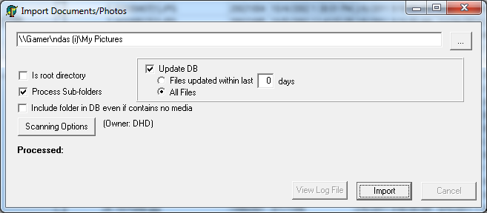

* Browse to the folder which contains the photos or documents that you wish to import
* The “Scanning Options” button will present the “Scanning Options” dialog:

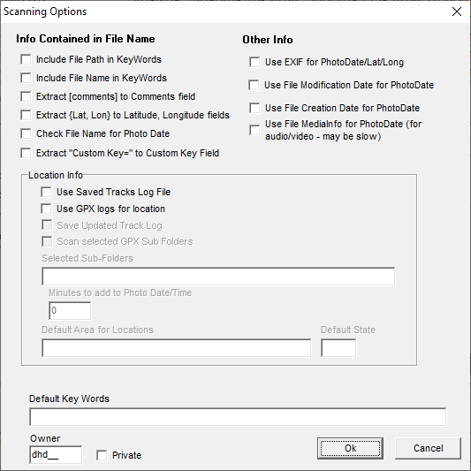

* The scanning options are:
  + **Include File Path in KeyWords:** this will include important words from the file's path as keywords.
  + **Include File Name in KeyWords:** This will include words from the file's name in the key words. You might want file names like “John Doe; Denver.jpg” to be included in the key words but not want “IMG_1234.jpg” to be included in the key words. “Noise “words” like “jpg” will be stripped and not included.
  + **Extract [Comments] to Comments field:** When manually naming photos (prior to importing into PhotoDB), you can use a name like “John Doe [this is only a comment].jpg”. This would import “John Doe” into the Key Words field, but would import “this is only a comment” into the Comments field.
  + **Extract {Lat,Lon} to Lattitude, Longitude field-** When manually naming photos (prior to importing into PhotoDB), you can use a name like “John Doe {42.8679850 -77.2459800}.jpg”. This would import “John Doe” into the Key Words field, but would import “42.8679850 -77.2459800” into the Location field.
  + **Check File Names for Photo Date**: if the file name includes a date, this option allows it to be extracted from the file name and placed into the date fields. For example, a photo named “19870323 John Doe.jpg” would be given a PhotoDate of 3/23/1987. Acceptable date formats include:
    - YYYYMMDD
    - YYYYMM
    - YYYY
    - (other date formats may also be found)
  + **Extract “Custom Key=” to Custom Key Field-** if the file name includes a *custom key*, this option allows it to be extracted from the file name and placed into the custom key field. For example, a photo named “MyKey= John Doe.jpg” would be given a Custom Key of “MyKey”.
  + **Other Info-** Choose where the PhotoDate of scanned records will be taken from
    - **Use EXIF for PhotoDate/Lat/Lon**
    - **Use File Modification Date for Photo Date**
    - **Use File Creation Date for Photo Date**
    - **Use File MediaInfo for Photo Date-** (for audio/Video – may be slow)
  + **Location Info**
    - **Use GPX Logs for Location:** It is possible to Geo Locate photos by comparing the date/time that a photo was taken with the times recorded by a GPS receiver. If this option is selected, GPS data (GPX) files will be scanned for matching date/times and the corresponding location found will be used to specify the location where a photo was taken.
    - **Saved Updated Track Log:** scanning GPX data files can be a time-consuming operation if there are a lot to scan. This option will compact the important information from GPX data files into a simple “comma delimited” Saved Track Log for faster access.
    - **Scan GPX Sub-Folders:** in addition to scanning a single folder for GPX data files, this option will also scan all of its sub-folders.
    - **Scan Selected GPX Sub-Folders:** This permits the scanning on only selected Sub Folders. The selected sub-folders are entered by name. For example: “2015;2016” in which the names are separated by semi-colons.
    - **Minutes to Add to Date/Time:** If it is necessary to adjust all of the photo dates and times as they are being imported (if, for example, the time set in the camera is incorrect), this option be be used. This can also be a negative number.
    - **Default Area for Locations:** If set, this will cause all location names to be created using the specified name-- for example: “Yellowstone National Park”.
  + **Owner:** this is a three letter “Copyright” code to be used for all of the photos / documents being imported. The meaning associated with the codes can be looked up using the Copyrights table.
  + **Private-** Specifies whether the scanned documents should all have the “private” setting set or not.
    1. **Save Photo As-** This menu option can be used to save a single photo (or document) to a file.
    2. **Move File-** This can be used to move a photo to a different folder (within the overall directory tree )
       - This will copy the currently selected photo of document to a specified location.
       - It is also possible to Drag-and-Drop a photo or document from the “Photo” tabsheet.
    3. **Print:** This will print the currently selected page to the default printer. No formatting is done.
    4. **Options:**

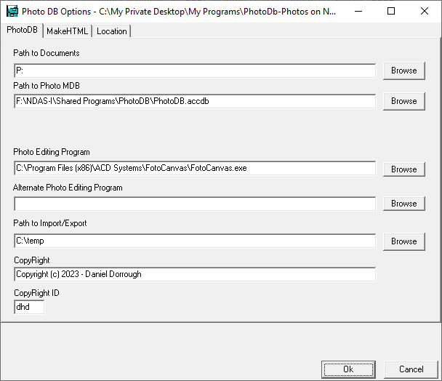

* + - 1. **PhotoDB Tab**
         1. **Path to Documents:** The is the path to the root of the file system containing the photos / documents
         2. **Path to Photo MDB:** This is the path to the MS Access database (.ACCDB) which contains all of the document info used by PhotoDB
         3. **Photo Editing program:** This is the file/path to the program to be used when editing a photo (such as FotoCanvas.exe or PhotoShop.exe)
         4. **Alternate Photo Editing Program:** This is the path to an alternate photo editing program which can be used (such as “Paint.exe” or “Photos.exe”)
         5. **Copyright**
         6. **CopyRight ID:** this is the 3-letter copyright ID which will be used when importing photos / documents.
      2. **MakeHTML tab**
         1. **Next Folder Number:** Each folder in the documents folder will be given a number bases on “Next Folder Number”. This number is automatically maintained but could be manually updated. If the number becomes de-synchronized
         2. **Scan Button-** This can be used to scan and recalculate the next folder Number
         3. **Reference CSS Locally-** if checked, when generating HTML (in the Utilities Menu, the local CSS file name will be used. If not checked, the Remote CSS file name will be used.
         4. **Local CSS File Name**
         5. **Remote CSS File Name-** for example: “http://RuthAndDan.net/MyStyle.css”
    1. **Exit**
  1. **Edit Menu**
     1. **Photo Editor:** this will invoke your selected photo editor on the currently selected photo. The photo editor is specified using the *File Menu, Options, Photo Editing Program*.
     2. **Find Keyword:** this will search through all of the currently selected records for the specified keywords for a record with those keywords.
     3. **Find String:** this will search through all of the fields of all of the currently selected records for a record containing the specified string.
     4. **Find Again:** this will repeat the last search.
     5. **Goto Key:** this will locate the record having the specified key value.
     6. **Copy Full Filename:** This will copy the full filename of the currently selected record so that it can be pasted into some other program.
     7. **Rename File:** this can be used to rename a file. The filename field is not editable on the *Photo* tabsheet. This will not change the files location.
  2. **Navigate** **Menu**
     1. **First:** move to the first record in the currently selected order.
     2. **Prev:** move to the previous record in the currently selected order.
     3. **Next:** move to the next record in the currently selected order.
     4. **Last:** move to the last record in the currently selected order.
     5. **Delete:** delete the currently selected record
     6. **Mark/Next:** set the “Date Updated” field of the current record to the current date and time and then move to the next record.
     7. **Post:** save any editing changes made to the currently selected record.
     8. **Refresh**
     9. **Order –** selects the order in which records will be ordered / processed. Here are the possibilities:
        1. File Name
        2. Path / Name
        3. Photo Date
           1. Ascending
           2. Descending
        4. Photo Date/Time
           1. Ascending
           2. Descending
        5. File Size
        6. (recno) – i.e., unordered
        7. Date Updated
        8. Date Added
        9. Latitude
           1. Ascending
           2. Descending
        10. Longitude
            1. Ascending
            2. Descending
        11. Media Length
        12. Custom Key
        13. Distance from Locations
        14. In Order by Lat, Lon
  3. **Insert Text Menu**
     1. **Insert Text:** each of the function keys may be assigned an arbitrary string of text which can be inserted into the *KeyWords* field. These text strings are stored in the *Function Keys Lookup* table.
     2. **Insert Shift Text:** each of the shifted-function keys may be assigned an arbitrary string of text which can be inserted into the *KeyWords* field.
     3. **Insert Ctrl Text:** each of the ctrl shifted function keys may be assigned an arbitrary string of text which can be inserted into the *KeyWords* field.
     4. **Print Key Assignments:** The current function key assignments are written to a text file which is opened and can be printed. These values are taken from the *Function Keys Lookup* table.
     5. **Browse FuncKey Values:** This opens the *Function Keys Lookup* table which contains function key assignments for editing.
  4. **Image Menu**
     1. **Rotate Right 90**- rotates a photo clockwise by 90 degrees
     2. **Rotate Left 90-** rotates a photo counter-clockwise by 90 degrees
     3. **Rotate 180-** rotates a photo by 180 degrees
     4. **Show EXIF/Media Info-** This opens up another window which displays EXIF info for the current photo or video.

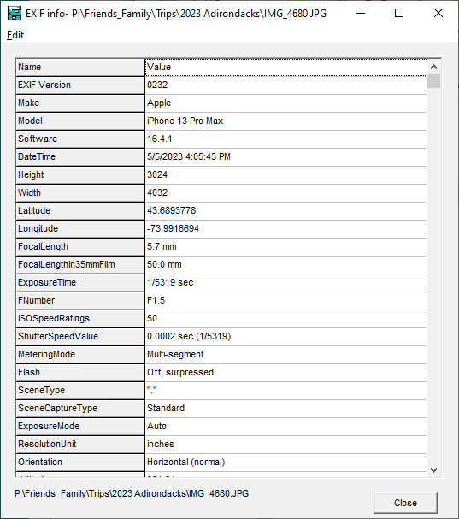

* 1. **Utilities**
     1. **Fill**
        1. **Fill Year, Month, Day, PhotoDate**
           1. **From File Date/Time:** This uses the file's *modified* date to fill the date/time fields for all of the selected records.
           2. **From File Creation Date/Time:** This uses the file's *creation* date to fill the date/time fields for all of the selected records.
           3. **From EXIF Date/Time:** This uses the EXIF “Date Taken” field from a JPEG photo to fill the date/time fields for all of the selected records.
           4. **From Entered Date/Time:** This uses the date/time entered by the user to fill the date/time fields for all of the selected records.
           5. **From Media Date-** This uses media info for the each selected media (video) to fill the date/time fields.
        2. **Fill PhotoDateTime from PhotoDate-** This attempts to convert the *PhotoDate* value from YYYYMMDD format to a valid *PhotoDateTime*. Since the *PhotoDate* field may not contain a valid date (the MM and DD might be missing for example) the conversion may fail the *PhotoDateTime* may be left empty.
        3. **Fill PhotoDate from PhotoDateTime:** This will fill the *PhotoDate (YYYYMMDD)* field from the *PhotoDateTime* field. This extracts the date portion of a valid PhotoDateTime field and converts into the YYYYMMDD format for a PhotoDate field.
        4. **Fill Year, Month, Day**
           1. **From PhotoDate**
           2. **From PhotoDateTime**
        5. **Fill Location**
           1. **from GPX data files**

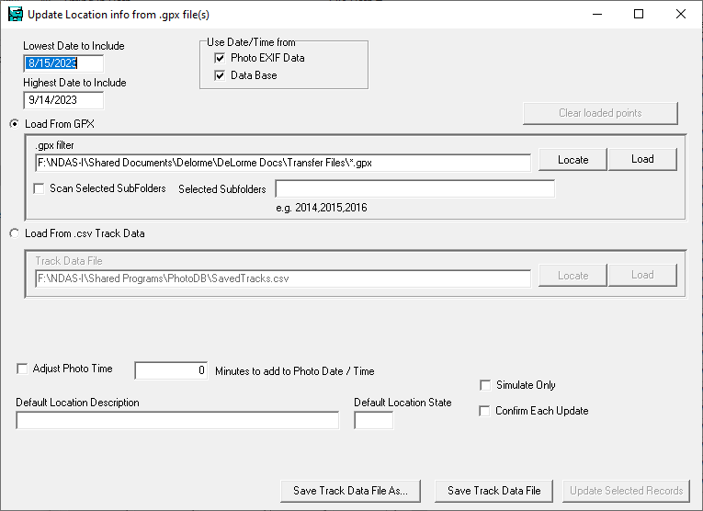

This function will scan all of the GPS (*.GPX) data files in a specified location. Each of the currently selected records will be compared against the dates/times stored in the GPX data. The Latitude/Longitude from the GPX data will be used to create a *Location* record for that location. The *Location ID* of that record will be added to the database record for each photo and the *Latitude* and *Longitude* will be added to the photo record.

**Lowest Date to include:** use this to limit the number of locations which will be loaded into memory.

**Highest Date to include:** use this to limit the number of locations which will be loaded into memory.

**Load From GPX:** this is used to specify the location where the GPX records are stored.

**Locate:** this can be used to browse to the location containing the GPX data files.

**Load:** this will load all of the GPX files from the specified location into memory.

* + - * + **Load from CSV Track Data:** Loading many GPX data files can be a very time consuming operation. To save time, once GPX data files have been loaded into memory, the critical data (date, time, latitude, longitude) can be saved into a simple “comma delimited text file” (“SavedTracks.csv”) for much faster loading and data access.
        + **Adjust Photo Time:** for the Geo Location process to work, the Photo Dates and Times must be accurate with respect to the dates and times recorded in the GPX tracks. If the photos were taken with an incorrect date/time setting in the camera, it may be necessary to adjust the dates/times used. This field, will add or subtract a specified number of minutes the date/time used to geo locate each photo.

**Use Date/Time from**

**Photo EXIF Data:** use the date/time recorded in the photo's EXIF information.

**Data Base:** use the date/time recorded in the databases's *PhotoDateTime* information (this information may have been entered manually, or from the file's date/time, or adjusted some other way). If both of the options are specified, the EXIF information will take precedence.

**Simulate Only:** if you are unsure about settings (particularly the *Minutes to Add* setting), check the *Simulate Only* check box. This will count the number of records which would be updated, but won't actually update them.

**Save Track Data File:** the location data currently loaded into memory will be saved to the specified track data file (“SavedTracks.csv”).

* + - * 1. **Clear location ID for Selected Records**
        2. **Fill Location from Entered Data**

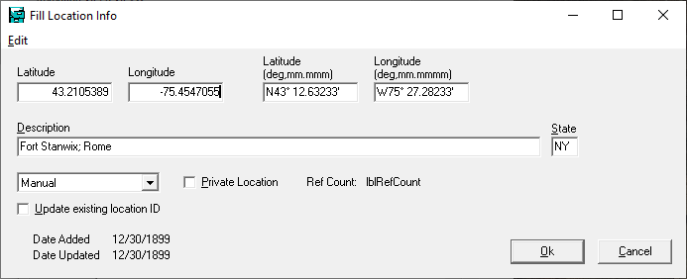

* + - * + This function can be used to set the location info (*Location ID, Latitude & Longitude)* for all selected records. If a *Location Table* record exists for the Lat/Lon specified, it will be used. If a matching *Location Table* record does not exist, one will be created.
        + The Latitude & Longitude can either be specified as decimal degrees or as Deg, Min Sec. The Description is used to give a name to the location. *State* is the State where the photo was taken. The drop down can specify where the data was obtained (Photo EXIF, GPS Logs or entered manually).
        1. **Fill Location from EXIF:** The selected records will be scanned and any records which include Latitude & Longitude will be used to create location records for each photo and to add latitude and longitude to the database record.
      1. **Fill File Size:** All selected records will be scanned the size of the referenced file will be entered into the *File Size* field.
      2. **Fill “Date Added” from File Date:** All selected records will be scanned and the file's date field will be used to fill the *Date Added* field.
      3. **Fill Latitude/Longitude from Location ID:** ordinarily, the *Location ID and Latitude* and *Longitude* fields are automatically kept synchronized. If, for some reason, the *Latitude* and *Longitude* fields have not been entered, this function will fill the *Latitude* and *Longitude* fields from records in the *Locations Table.*
      4. **Fill Height/Width for Selected Photos:** The *Height and Width* fields are ordinarily automatically updated when a photo is added to the database. If, for some reason, the *Height* and *Width* fields have not been entered, this function will fill the *Height* and *Width* fields from the photos height and width.
      5. **Fill TextInFile with Text from file:** The database has a memo field named *TextInFile* which can be used contain the complete text from a text file. This information can be used in searches. This function will scan text files, including PDF files and add the text to the *TextInFile* memo field.
      6. **Fill WasScanned from EXIF:** The database tries to distinguish between photos that were taken with a digital camera and those that were merely scanned. This function tries to guess where the photo originated and fill the field *WasScanned* appropriately. A photo is assumed to have been scanned if the EXIF information does not indicate a camera make or model or if the photo was taken before the (arbitrary) date of July 1, 1998.
    1. **Browse**
       1. **Browse File Paths:** View the *FilePaths* table. This table contains a record for every path where photos are stored.
       2. **Browse Copyrights:** View the CopyRights table. This table is used to keep track of who took each photo or who a document belongs to.
       3. **Browse Locations:** View the *Locations* table. The *Locations table* may contain one record for each location where photos were taken. Multiple photos may refer to the same location.
       4. **Browse Boundaries:** The *Boundaries Table* contains one record for each rectangular geographic region of interest. These regions may be used to locate all photos taken in a specific geographic region. The table contains the following fields:
          - ***Abbrev –*** and abbreviation for the region name
          - ***Description*** – a description of the region
          - ***BRTop*** – the Northern longitude of the region
          - ***BRLeft*** – the Western latitude of the region
          - ***BRBottom*** – the Southern longitude of the region
          - ***BRRight*** – the Eastern latitude of the region
          - ***Date Added***
          - ***Date Updated***
          - ***File Names:*** this may contain a list of the GPX data files that are contained in the region.
       5. **Browse Scenes:** when a record in the database refers to a video file (rather than a photograph) it is useful to have a list of the scenes contained in that file. This function will browse that file. Details about the contents of that file may be found elsewhere.
       6. **Browse FileNames:** This will display records from the *FileNames* table. This information is also seen on the “*Filter”* tabsheet.
       7. **Browse Lookups**
          - The *Lookups Table* is used to store various kinds of information used in pop-ups used throughout the program. Some of the pop-ups include: *Saved Expressions, Saved Filters, Function Keys* and *Help.*
          1. **All Lookups**
          2. **Saved Expressions**
          3. **Saved Filters**
          4. **Function Keys**
          5. **Noise Words**
          6. **Synonyms**
    2. **Count Selected Records:** This function will count the number of currently selected records. The result will be shown in the lower left-hand corner of the screen.
    3. **Calculate Total Size for Selected Files:** This function will scan currently selected records and accumulate the size of the referenced files. The result will be shown in the lower left-hand corner of the screen.
    4. **Add Keyword to Selected Records:** This function will add a user-specified key word to all of the selected records. If a record already contains the key word, it will not be added a second time.
    5. **Replace Text in Selected Records:** This function should replace one user specified keyword in a group of selected records with a different user specified key word.
    6. **Copy Selected Records** : This function will copy all of the files referenced by currently selected records to a different location. The created files may be renamed using the current date, the folder name, the current file name, an index number, the location description, the location number and/or the comment. This might be useful when creating filenames based on the date so as to allow the files to be sorted by date ignoring the original file name.

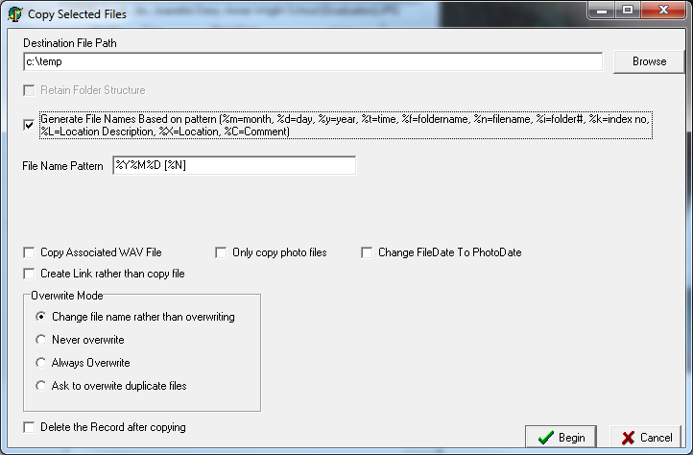

* + - **Destination File Path**
    - **Retain Folder Structure**
    - **Generate Filenames based on Pattern**
    - **File Name Pattern**
    - **Copy Associated WAV file**
    - **Only Copy Photo Files**
    - **Change File Date to Photo Date**
    - **Create Link rather than Copy File**
    - **Overwrite Mode**
    - **Delete the Record After Copying**
    1. **Update Field in Selected Records –**

Answer “Do you want to confirm each record?”

Specify Field to Modify

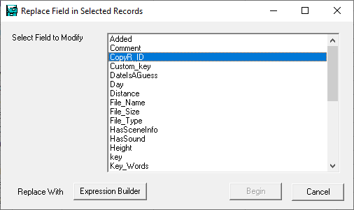

Use the Expression Builder to enter an expression which will be calculated and entered into the field for each selected record.

* + 1. **Set FileDateTime to PhotoDateTime**
    2. **Update Thumbnails for Selected Records**
    3. **Adjust Photo Dates/Times-** This function can be used to adjust the PhotoDateTime all selected records.

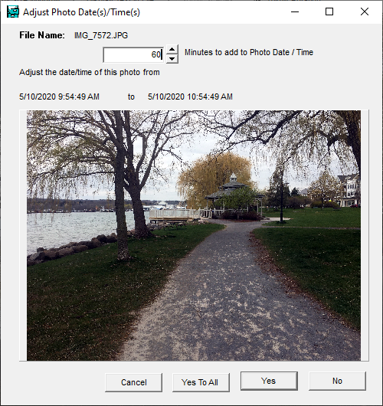

* + 1. **Generate HTML for Selected Records**

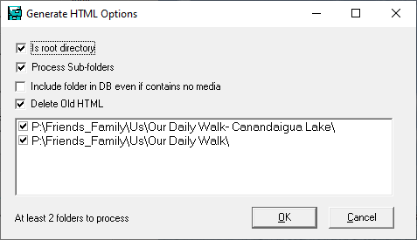

* + 1. **Export Selected Records-** This will export the selected records into the specified output database. You may optionally also copy the referenced documents (photos) to the same location. This could be used to export a portion of the “main” database to a remote copy.

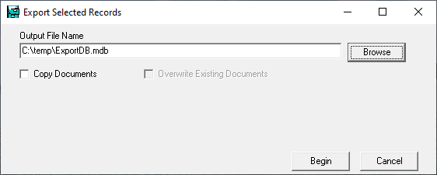

* + 1. **Import Records-** This will import the contents of another (previously exported) database into the current database. Documents (photos) can also be copied from the specified location into the documents area of the current database. Records will not actually be updated unless “Update Records” is checked.

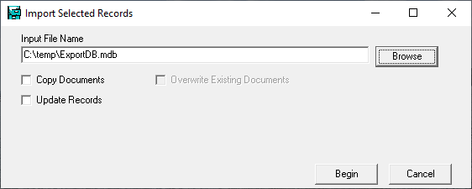

* + 1. **Miscellaneous**
       1. Date/Time Calculation- This can be used to calculate the time difference between two dates and/or times.

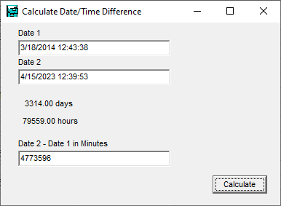

* + - 1. Delete Trailing Dates
      2. Rate Photos
      3. Match Selected Files to Files in Folders
      4. Delete Selected Records
      5. Search for Lat / Lon
      6. Generate POI file
      7. Rename Files in Folder to Date/Time Taken
  1. **Reports**
     1. **Scan for Missing Files-** This will scan the directory structure and report on any photos / documents that could not be found.
     2. **Scan for Missing Files and Update-** This will scan the directory structure and report on any photos / documents that could not be found and also delete the records associated with missing photos / documents.
     3. **Scan for Files not in Database-** This will scan the directory structure and report on any photo / documents that haven’t been added to the database.
     4. **Scan for Duplicates-** This will scan the currently selected records and report on records which appear to be duplicates. That is to say, records adjacent to each other in the specified sort order which are similar. Duplicate records can also be deleted with the user controlling which of the duplicates should be deleted.

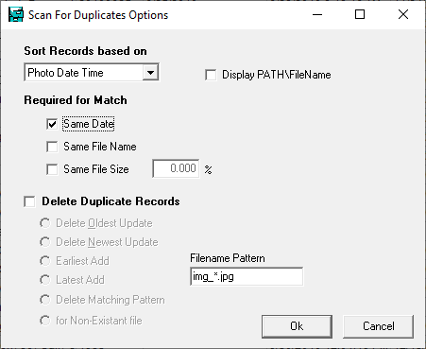

* + 1. **List Selected Records-** This generates a report listing the selected records. The report can optionally list (1) the file name, (2) the photo date, (3) the file path, (4) the key words, (5) location info and/or (6) the Copyright Owner (COPY_ID). The file names listed in the report can optionally be reformatted to match the specified pattern.

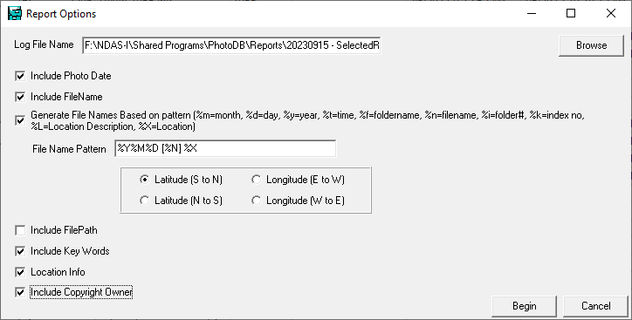

* + 1. **Duplicate File Size Report**
    2. **Scan for Missing Thumbnails-** This will list all of the currently selected records which do not have a corresponding thumbnail file in the thumbnail (“TN\*_TN”) folder.
    3. **Browse Reports Folder-** This will display all of the files currently contained in the Reports folder and can be used to open one of them.

Notes:

* Program Parameters
* Note use of terms “photo” 🡨🡪 “document”